COMPANY PROFILE

**OF**

**ISD HYGIENE AND TROLLEY SERVICES (PTY) LTD**

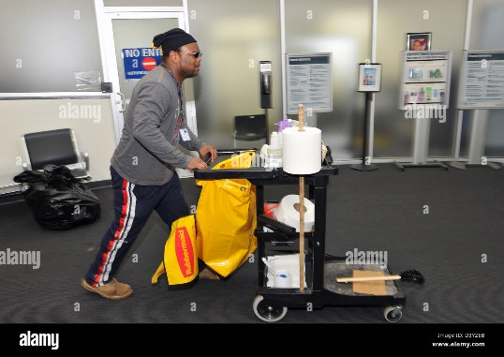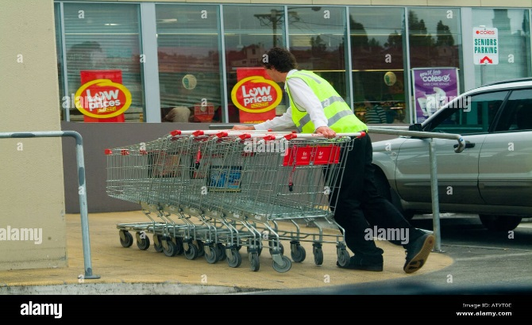



E

|  |  |
| --- | --- |
| **DESCRIPTION** | **DETAILS** |
| COMPANY NAME | ISD HYGIENE AND TROLLEY SERVICES (PTY)LTD |
| CO. REG NO | 2025/146864/07 |
| MOBILE | 068 480 0244 |
|  |  |
| E-MAIL ADDRESS | Dlamininqubeko55@gmail.com |
| BB-BEE STATUS | LEVEL 1 CONTRIBUTOR |
| INCOME TAX NUMBER | 9326900256 |
| DIRECTOR | MR. NQUBEKO MLONDI DLAMINI |

|  |  |
| --- | --- |
| COMPANY ADDRESS | L 365 |
|  | SIZENZE ROAD |
|  | KWAMASHU |
|  | DURBAN |
|  | 4360 |

# BRIEF DESCRIPTION

ISD HYGIENE AND TROLLEY SERVICES (PTY) LTD is a 100% black youth-owned company registered in 2025

The company has vast experience in the cleaning and hygiene industry. The owner /Director of this company has been involved in this line of work for more than (04) four years.

The owner has worked, as an employee and has on-the-ground experience on the practical side as well as management side.

History of this company dates back in year 2019 (before formally registering ) when its owner and its incorporator saw a gap in the market to apply his skills and indirectly benefit the people of Ethekwini firstly and subsequently of KwaZulu Natal. Profit –motive was never an objective of this company but skills transfers is of paramount importance.

ISD HYGIENE AND TROLLEY SERVICES (PTY) LTD prides its self for successfully completing projects before and after formally registering, as a formal and complying entity. Whilst we have a qualified and competent workforce, we do up-skilling on them to keep up with the ever changing technologies in our areas of work.

# MISSION STATEMENT

ISD HYGIENE AND TROLLEY SERVICES (PTY)LTD has come all the way from the disadvantaged background and today we are a well-recognized business which has showed so much improvement within a short period of time.

We have been very loyal and trustworthy to all our main Customers as custodians of their offices/Malls/Shopping Centers.

We are a company that have been very dedicated to its work by ensuring that we finish what we start, we have created a good record for our company across KZN by ensuring that whenever we go we leave a better name, our pricing a very reasonable compared to other well-known companies.

# CLEANING COMPANY

We tend to believe that we are the best company to work for, we don’t take chances, we deliver what is expected of us at all times, we have been in the industry from 2019 but our company was has been existing behind the scenes by conducting some cleaning to private and other state entities work, from all our previous experience we had some challenges but we always respect all our clients by delivering what is expected

We always create a smooth platform even when other situations we are forced to adapt to difficult situation

# BUSINESS STRATEGY

We are currently based within the KZN region but our goal is to provide our services throughout the whole of South Africa including the nearby cities in KZN like Johannesburg Cape Town and many more others

Our statistics have proven that we deliver the best cleaning services and other related business work, We have been involved in so many projects that require us to produce the best in the region.

We tend to believe on our employees by ensuring that we hire well trained individual at all times, We also make sure that we train all our employees which is one of the reason that makes us who we are today

# RESPECTING OUR CLIENTS

We have always been very loyal, our clients are our number one priority when it comes to business.

Our strategy is to respect all our clients and treat them equally, and also deliver what is expected of us without fail, and also we tend to have one strategy to always listen to our client’s requirements at all times.

# BUSINESS CONCEPT

ISD HYGIENE AND TROLLEY SERVICES (PTY)LTD is a Cleaning and Management that special on the a variety of activities.

Below is what we specifically specialize on:

* Office Cleaning Services
* Buildings Cleaning Services
* Shopping Malls Cleaning Services
* Specialised Domestic Cleaning Services
* Parks Maintanance And Garden Services

Other Business Activities

* Trolley Management Services

The target market of our products and service, among others, are:

* Businesses
* Municipalities
* Private & Public companies
* Private Households / Individuals

# ATTACHMENTS

Please find attached documentation in support of our business having complied with